Survey Central

1. Closed-Ended Questions

1.1 Closed-Ended Questions
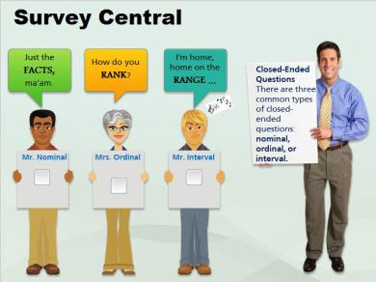
Notes:
Closed-Ended Questions
There are three common types of closed-ended questions: nominal, ordinal, or interval.

1.2 Ordinal
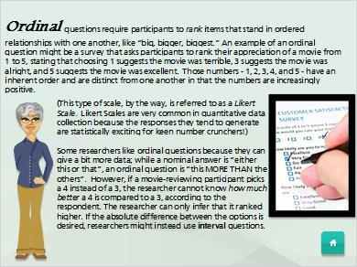
Notes:
Ordinal questions require participants to rank items that stand in ordered relationships with one another, like “big, bigger, biggest.” An example of an ordinal question might be a survey that asks participants to rank their appreciation of a movie from 1 to 5, stating that choosing 1 suggests the movie was terrible, 3 suggests the movie was alright, and 5 suggests the movie was excellent. Those numbers - 1, 2, 3, 4, and 5 - have an inherent order and are distinct from one another in that the numbers are increasingly positive.

(This type of scale, by the way, is referred to as a Likert Scale. Likert Scales are very common in quantitative data collection because the responses they tend to generate are statistically exciting for keen number crunchers!)

Some researchers like ordinal questions because they can give a bit more data; while a nominal answer is “either this or that”, an ordinal question is “this MORE THAN the others”. However, if a movie-reviewing participant picks a 4 instead of a 3, the researcher cannot know how much better a 4 is compared to a 3, according to the respondent. The researcher can only infer that it ranked higher. If the absolute difference between the options is desired, researchers might instead use interval questions.

1.3 Nominal

Notes:
Nominal questions require participants to select from named categories like “yes/no” or “Single/Married/Divorced/Separated/Other” or “Male/Female”. You will notice these categories cannot be arranged from “most” to “least” - a person simply picks one. In other words, a researcher could switch around the order of the choices and it would make no difference…unlike the two other kinds of answers participants are often asked to provide.

1.4 Interval
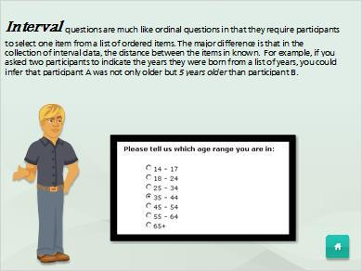
Notes:
Interval questions are much like ordinal questions in that they require participants to select one item from a list of ordered items. The major difference is that in the collection of interval data, the distance between the items in known. For example, if you asked two participants to indicate the years they were born from a list of years, you could infer that participant A was not only older but 5 years older than participant B.

